nasa swarmathon

high school division

2018 module companion guide



2018

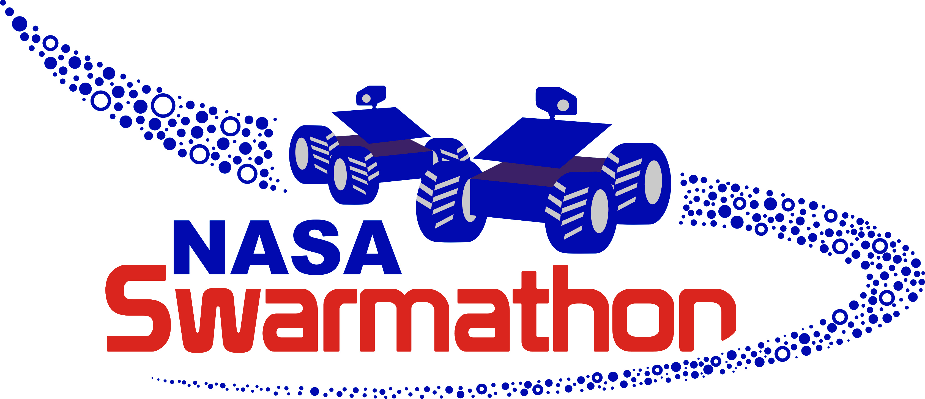

contents

# installing netlogo

## pages 3 – 5

# tips for running a workshop

## pages 5 – 7

# module summaries

## pages 7 – 8

# faq

## pages 8 - 9

# installing netlogo

## required version

You must use NetLogo 5.2 to participate in the NASA Swarmathon High School Division competition. NetLogo 5.2 is a stable release from April 2015.

Submissions saved in other versions of NetLogo, *including 5.2.1*, will automatically be disqualified.

## where to get it

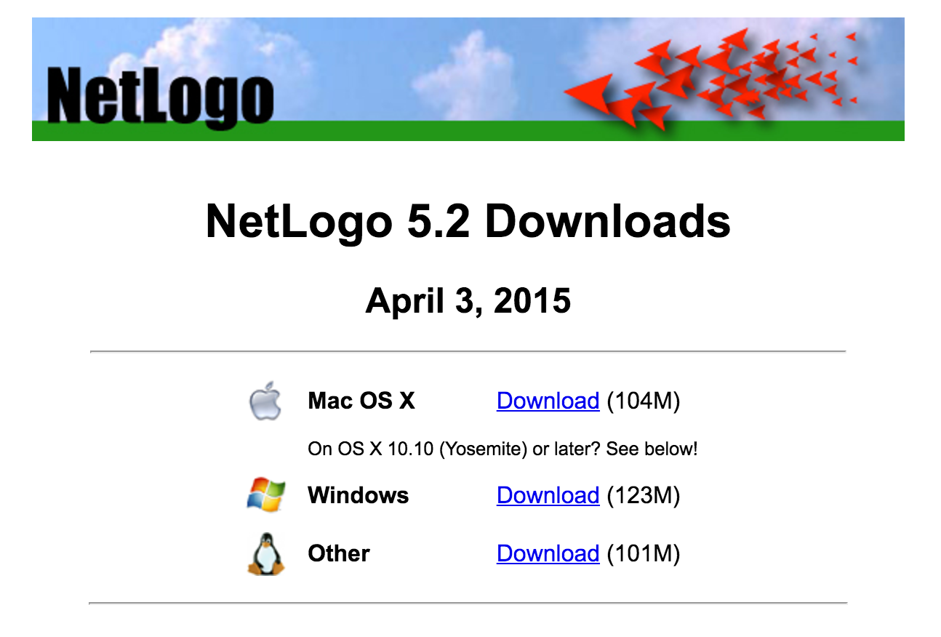You can download NetLogo 5.2 for Mac, Windows, and Linux at <http://ccl.northwestern.edu/netlogo/5.2.0/>.

## java

NetLogo 5.2 requires Java 6 to run. Later versions of Java will not suffice. Your system functionality will not be negatively impacted by having multiple versions of Java on your computer.

Please note that if you do not currently have Java 6 installed, the Windows NetLogo 5.2 installer will install it for you. Mac users will need to visit the following page to get Java 6 if it is not already installed: <http://support.apple.com/kb/DL1572?locale=en_US>

## required image files

[Sw1], [Sw2], [Sw3], and [Sw5] are all packaged with a required image file. The directories are already organized such that the base code and image file are in the same directory. Take care that this structure is preserved or your code will throw errors.

## test your installation

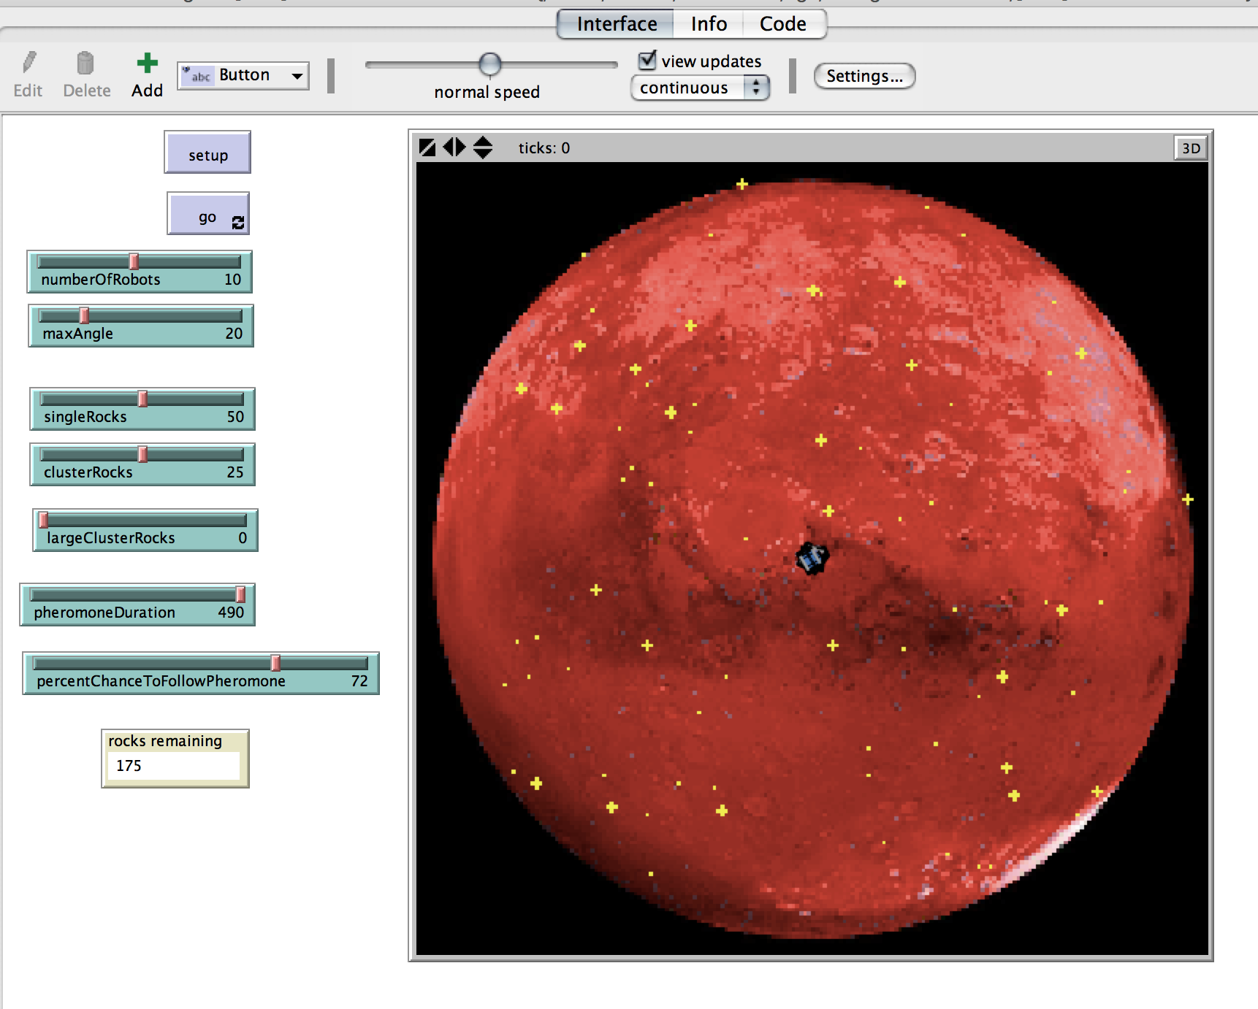Test your NetLogo installation by opening the file *[Sw2]AdvBioSearchstudentCode.nlogo*, taking care that the required file *mars.jpg* is in the same directory. Press the **setup** button. Your screen should appear similar to the picture below. Now press the **go** button. The robots should move around the simulated Mars planet, forage for rocks, pick them up, and drop them off at the base/origin.

## more resources

The excellent NetLogo Dictionary can be found here: <http://ccl.northwestern.edu/netlogo/5.2/docs/dictionary.html>

# tips for running a workshop

## timeline

Please refer to the timeline included in the Supporting Documents folder, which includes both required and recommended deadlines. It is important to give students as much time as possible between completing Module 4 and the code submission deadline to work on their competition submission. It is possible, but not recommended, to skip Modules 2 and 4.

## preparing for a workshop

We recommend allocating two members of your team to outreach. These two members should be sure to complete the modules before running the workshop. Other team members may also benefit from doing the modules and gain new ideas for their own Swarmathon strategy!

Our testers, who generally had several years of programming experience but little to no experience with agent-based modeling or NetLogo, were able to complete each module in 1 – 1.5 hours. This time also includes thoroughly reading the accompanying walkthrough.

Students will need access to NetLogo 5.2. Pair programming is encouraged, and is also a useful tool to employ when the number of students exceeds the number of available computers. You should budget for roughly 3 hours for the first workshop to allow time for your team members to help students get oriented. The remaining workshops should take roughly 2 hours.

## running a workshop

We have found that having at least two team members present is very helpful in a workshop. We have also found the following general workshop structure to be successful:

* Get the students excited about robots! Bring the Swarmies if you are a physical team or your simulation/show videos if you are a virtual team. Show them what you are working on.
* Briefly introduce concepts from the walkthrough as a team and tie them back to real robots.
* Get students setup with their base file.
* Team members take turns live-programming and helping students.
* Encourage students who finish early to experiment and/or start the next module.

If not everyone finishes the module, don’t worry. The walkthroughs lay out the steps to be taken step-by-step and students should be able to complete modules independently if necessary.

## strategies for competition success

Encourage students to look for ways they can combine the multiple strategies that have been introduced. There’s no right answer.

Be sure to read the competition rules in [Sw5] early along with your students. Encourage them to test [Sw1-4] with different resource distributions, and ask the following questions:

questions to ask students

Which strategies work best on which distributions? Why?

Is there a most efficient strategy?

If so, what are its weak points? How can you improve them?

# module summaries

NOTE: Multiple file formats and included images for each module walkthrough are provided for your convenience.

## [Sw1] Intro to Bio-Inspired Search

[Sw1] introduces NetLogo basics, random walking to find resources, and site fidelity.

## [Sw2] Advanced Bio-Inspired Search

[Sw2] builds directly on the code base from [Sw1]. Stigmergic strategy/using pheromone is introduced. Students also learn about variables that change value over time.

## [Sw3] Intro to Deterministic Search

[Sw3] introduces Depth-First Search (DFS). Students also learn about organizing code through procedures and subprocedures.

## [Sw4] Advanced Deterministic Search

[Sw4] that builds on the code base from [Sw3].  Students learn about spiral search and heterogeneous swarms.

## [Sw5] Competition

This module is the capstone project of the module progression and forms the students’ final submission for the HS Division competition. Students should be given as much time as possible to design, write, and test their solution. The module includes a Competition Guide with competition rules and a pre-submission checklist.

# faq

The FAQ will be periodically updated to reflect new problems and solutions as they arise.

## KNOWN BUGS AND WORKAROUNDS

BUG: [all .nlogo files] Double clicking on an .nlogo file to open it sometimes results in the file opening empty.

WORKAROUND: Don't panic! Open the file directly through NetLogo (File -> Open...). This a NetLogo thing and cannot be resolved from our end.

BUG: [Sw2] This module runs slower than other modules.

WORKAROUND: There's a lot of drawing going on with the multiple pheromone trails. You can speed it up a bit by changing view updates to on ticks on the Interface tab.

BUG: [SW3] When run at high speeds, the robots sometimes get "off track."

WORKAROUND: Decrease the speed slider to be on the slower side.

BUG REPORT? FEATURE REQUEST?

Email sherbet@unm.edu with the subject SwG report